September 2023
Thunderbolt Neighborhood Center
Monday | Tuesday | Wednesday | Thursday | Friday
1
9:30am Karaoke
10:45am Bingo
12:30pm Recipe
Squash Casserole
1pm Jeopardy

4 CENTER CLOSED  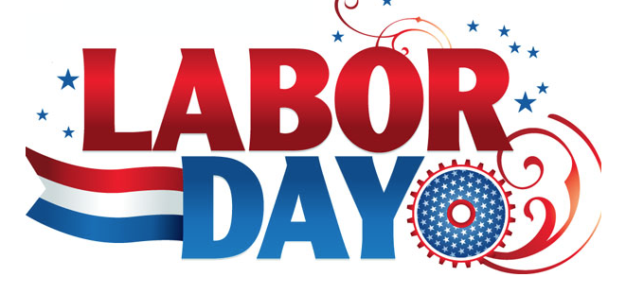 | 5  9:30am B-Fit Upper  10am Music & Manicures  11:00am Pictionary  12:30pm Scrabble  1pm Basketball | 6  9:45am Sun-Crest Karaoke Birthday  10:45am Jingo  12:30pm Book Club  1pm Tic. Tac. Toe | 7  9:30am Balloon Toss  10am Garden Craft  11am Learning Center Lecture  12:30pm Member’s Choice  1pm Corn Hole | 8  9:30am Karaoke  10:45am Bingo  12:30pm Recipe  Homemade Ice Cream  1pm Chess
11  9:30am Site Council/Fire Drill  10am Pet Engagement  10:45am Bingo  12:30pm Member’s Choice  1pm Putt- Putt | 12  9:30am B-Fit Lower  10am Mimosas & Manicures  11:00am 6 Exercise to prevent falls  12:30pm Table Games  1pm Basketball | 13  9:30am Walking Club  10:45am Well Care Jingo  12:30pm Jeopardy  1pm Tic. Tac. Toe | 14  9:30am Balloon Toss  10am Craft Corner  Flower Painting  11:00am Name that Tune  12:30pm Searching September  1pm Corn Hole | 15  9:30am Karaoke  10:45am Bingo  12:30pm Recipe  Apple Pie  1pm Rummikub
18  9:45am Brenda Moore Health Lecture  10:45am Bingo  12:30pm Member’s Choice  1pm Putt- Putt  Brown Bag Day | 19  9:30am B-Fit Upper  10am Nail Art  11:00am Side Effects of Low Carb Diet  12:30pm Trivia  1pm Basketball | 20  9:30am Walking Club  10:45am Jingo  12:30pm Back When  1pm Tic. Tac. Toe | 21  9:30am Balloon Toss  10am Craft Corner  Adult Coloring Book  11:00am Charades  12:30pm This Day in History  1pm Corn Hole | 22  9:30am Karaoke  10:45am Bingo  12:30pm Healthy Eating Q & A session  1pm Puzzle
25  9:30am Chair Exercise  10:45am Bingo  12:30pm Member’s Choice  1pm Putt-Putt | 26  9:30am B-Fit Lower  10am Afflins Hospice B/P Check  11:00am Older Adults and Financial Scams  12:30pm Puzzle  1pm Basketball | 27  9:30am UGA Jackie  10:45am Jingo  12:30pm Daily Chronicle  1pm Tic. Tac. Toe | 28  9:30am Balloon Toss  10am Craft Corner  Fall Decorating  11:00am Book Club  12:30pm Guess Who?  1pm Corn Hole | 29  9:30am Karaoke  10:45am Bingo  12:30pm Menu Chat  1pm Guess Who ?  Fall Festival
Kadijah Witter, Director
Thunderbolt Neighbor Center
3236 Russell Street
Thunderbolt, Georgia 31404
(912) 352-4846
Monday through Friday, 9 a.m. – 2 p.m.
*Activities subject to change

September Happenings

Sun Crest & GA House Calls Karaoke Birthday Party- Terrie Matthews &Ann Mattson 9/6

Learning Center Lecture- Debbie Hornsby 9/7

Lizzie the Comfort Dog- 9/11

Well-care Host Jingo- 9/13

Second Harvest Brown Bag Day 9/18

Brenda Moore Health Lecture 9/18

Affinis Hospice Health Lecture & BP Checkup- Melissa 9/26

UGA Jackie 9/27

9/29
Fall Festival- Wear Fall Colors

Happy Birthday
Deborah.T 9/6
Betty.C 9/16
Evelyn . F 9/22

